Jagjt SIngh Bilkhu

Lab 1

COMP 3410 – Operating Systems

T00533766

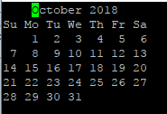mybirthday.txt

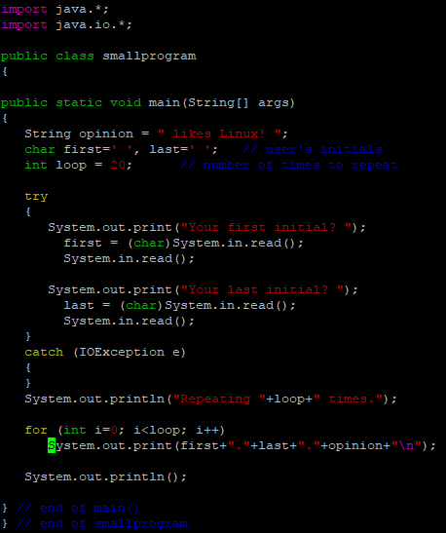smallprogram.java

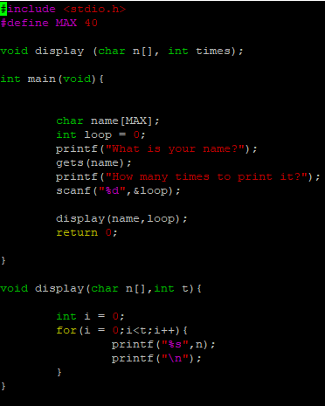smallprogram.c

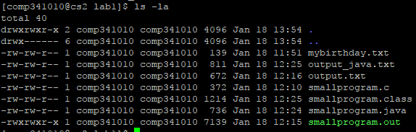

Listing of all files with permissions in lab_1 folder

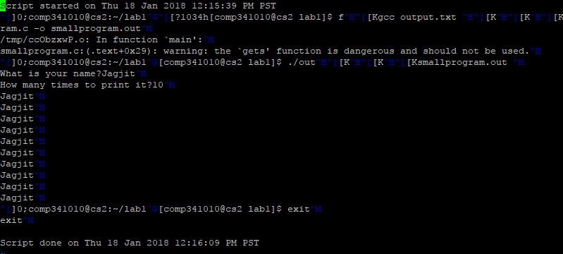Result of running smallprogram.out file

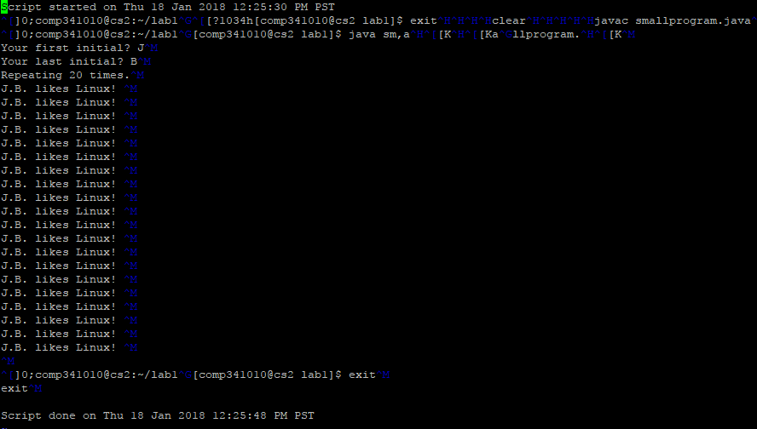

Result of running smallprogram.java

All the files from the lab1 folder from the Linux machine can be found in the attached zipped folder.

**Problems faced:**

* Using VI editor to type the code of the c and java files: indenting, saving and exiting files were confusing. Used spaces to indent and “Escape” after editing to enter :w to save and :q to exit